University Of Engineering and Technology, Lahore Computer Engineering Department

Course Name: PF | Course Code: CMPE-112L
Assignment Type: lab | Dated: 25 MAY 2026
Semester: 1st | Session: Spring 2026
Lab/Project/Assignment #: 12 | CLOs to be covered: CLO2
Lab Title: Lambda functions | Teacher Name: Hafiz Muhammad Mubashar

Lab Evaluation:

CLO1 | Apply appropriate programming techniques to create executable programs to solve well defined problems
 | Level1 | Level2 | Level3 | Level4 | Level5 | Level6
(5)
Total |  |  |  |  |  | /5

Rubrics for Current Lab Evaluation

Scale | Marks | Level | Rubric
Excellent | 5 | L1 | Submitted all lab tasks, BONUS task, have good understanding.
Very Good | 4 | L2 | Submitted the lab tasks but have good understanding
Good | 3 | L3 | Submitted the lab tasks but have weak understanding.
Basic | 2 | L4 | Submitted the lab tasks but have no understanding.
Barely Acceptable | 1 | L5 | Submitted only one lab task.
Not Acceptable | 0 | L6 | Did not attempt

LAB No 12

Lab Goals/Objectives:
- To understand anonymous functions.
- To create and use lambda functions.
- To write short and efficient code.
- To use lambda functions with built-in functions

Equipment Required:
- Computer/Laptop

- Python 3.x
- VS Code / PyCharm / IDLE

Theory:
A lambda function in Python is a small, anonymous function. "Anonymous" means it does not have a name like normal functions defined with def.It was introduced to write functions quickly without formally defining them.

Lab Work:

Task 1:
write the given Python program that uses normal `def` functions to calculate cube and square of a number by using lambda functions instead.

Result:
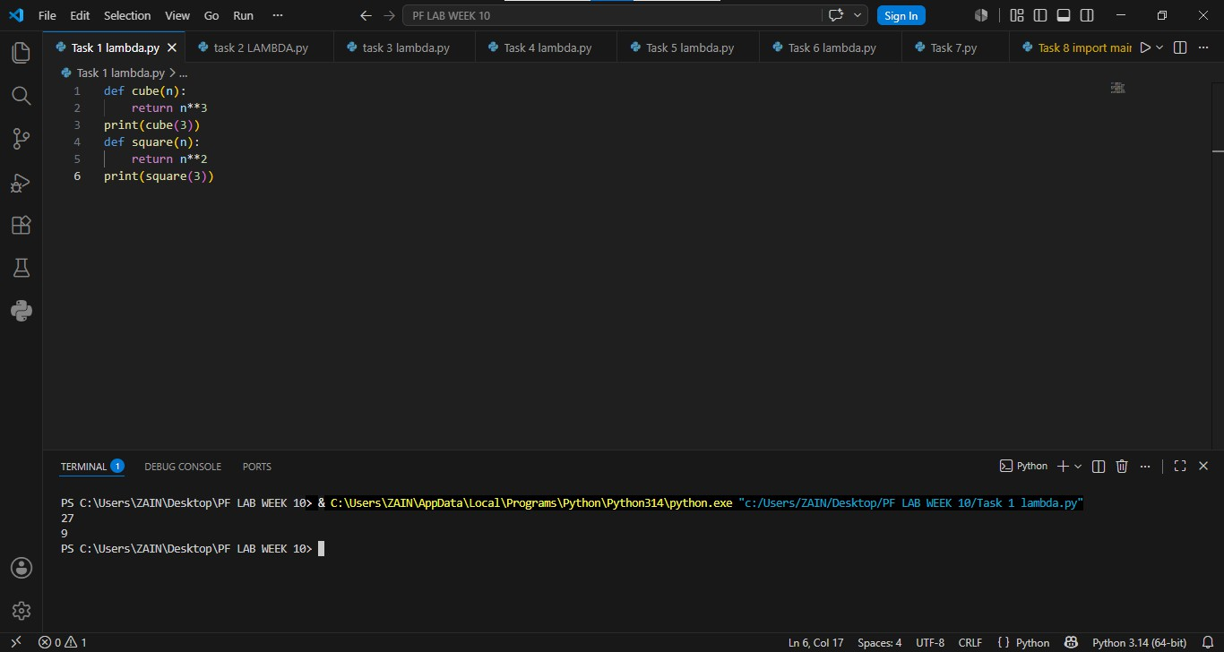

Task 2:

Write a Python program using a lambda function to calculate the cube of a number and print the result.

Result:
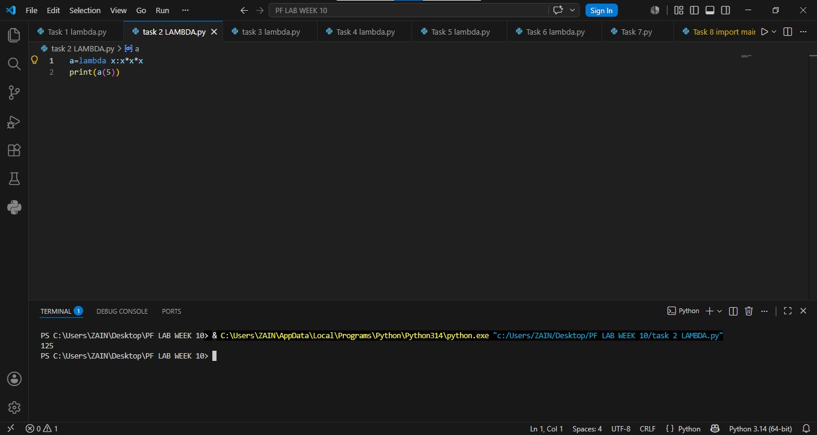

Task 3:
Write a Python program that uses a lambda function to calculate the sum of three numbers then print the result.
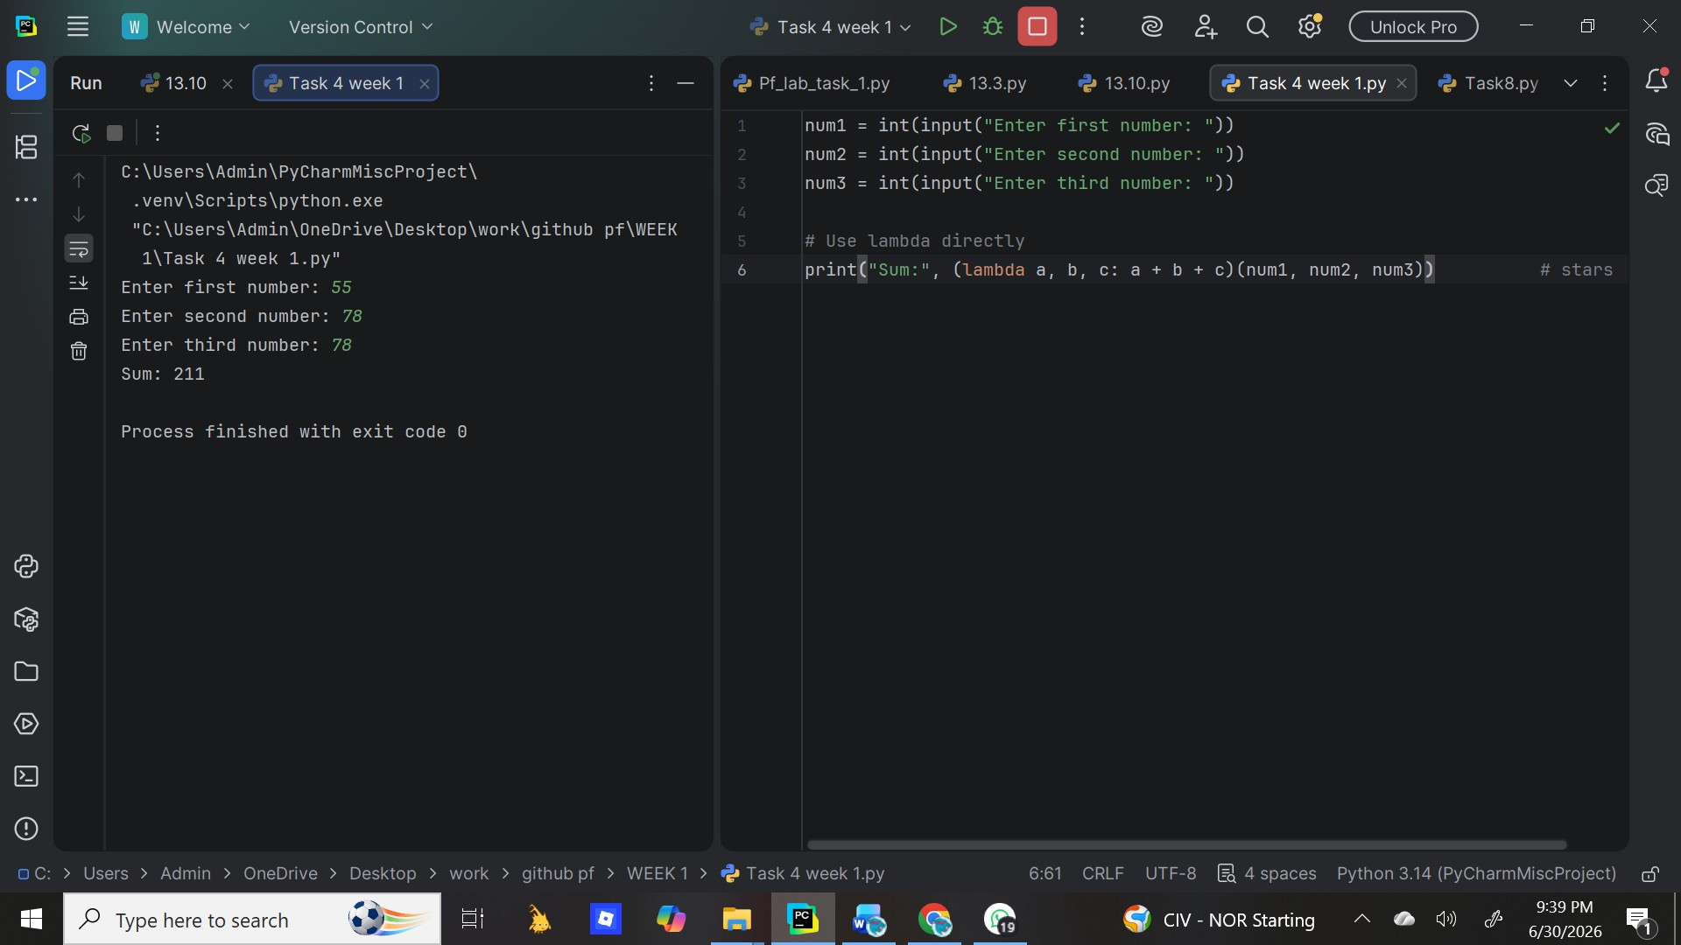
Result:

Task 4:

Result:

Write a Python program to create a lambda function that takes three numbers as input and returns their sum

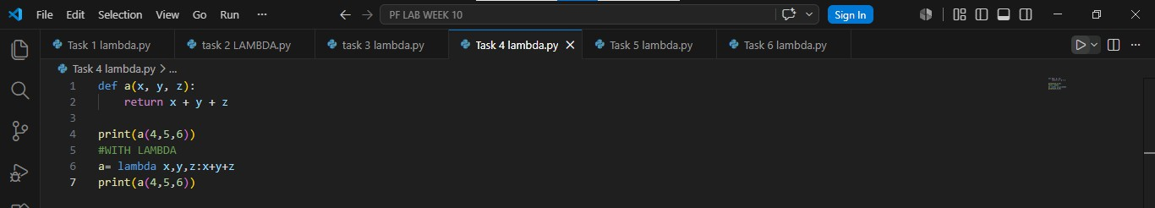

Task 5:
Write a Python program using a lambda function with the square all elements in the list and print the updated list.
Result:

Task 6:

Write a Python program using two lambda functions —
one to add two numbers and one to multiply two numbers

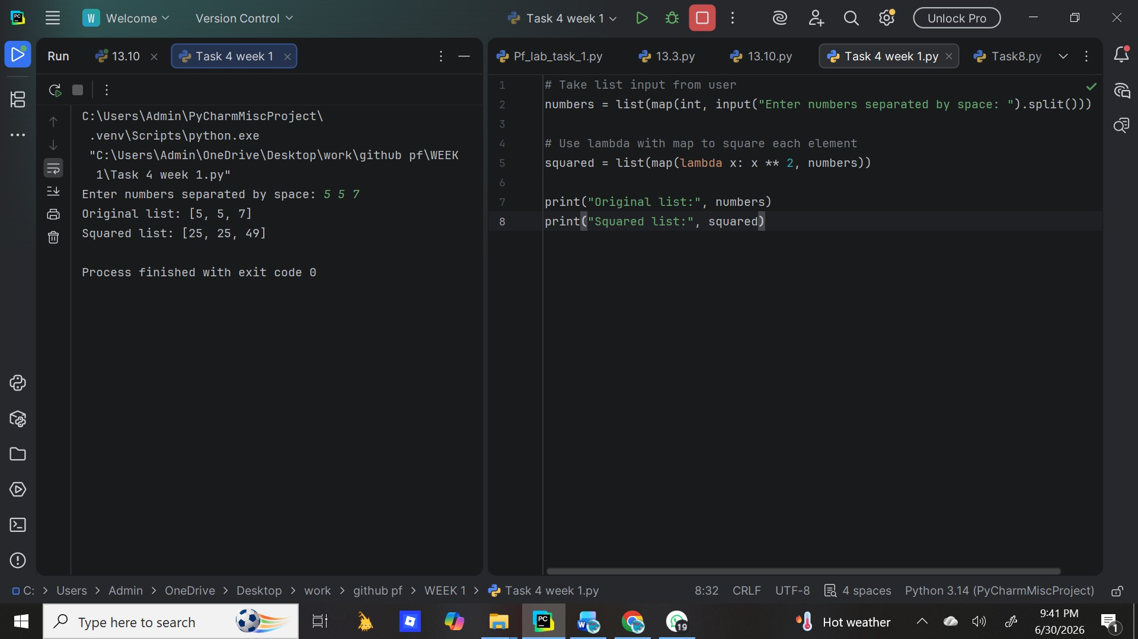
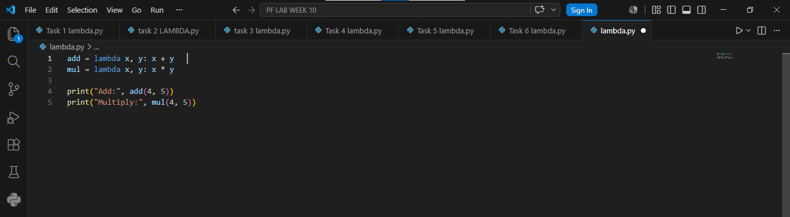

Result:

Conclusion
Lambda functions provide a quick way to write small functions inline. They make code shorter and cleaner, especially when used with map, filter, and sorted. However, for complex logic, normal def functions are preferred because they are more readable.

